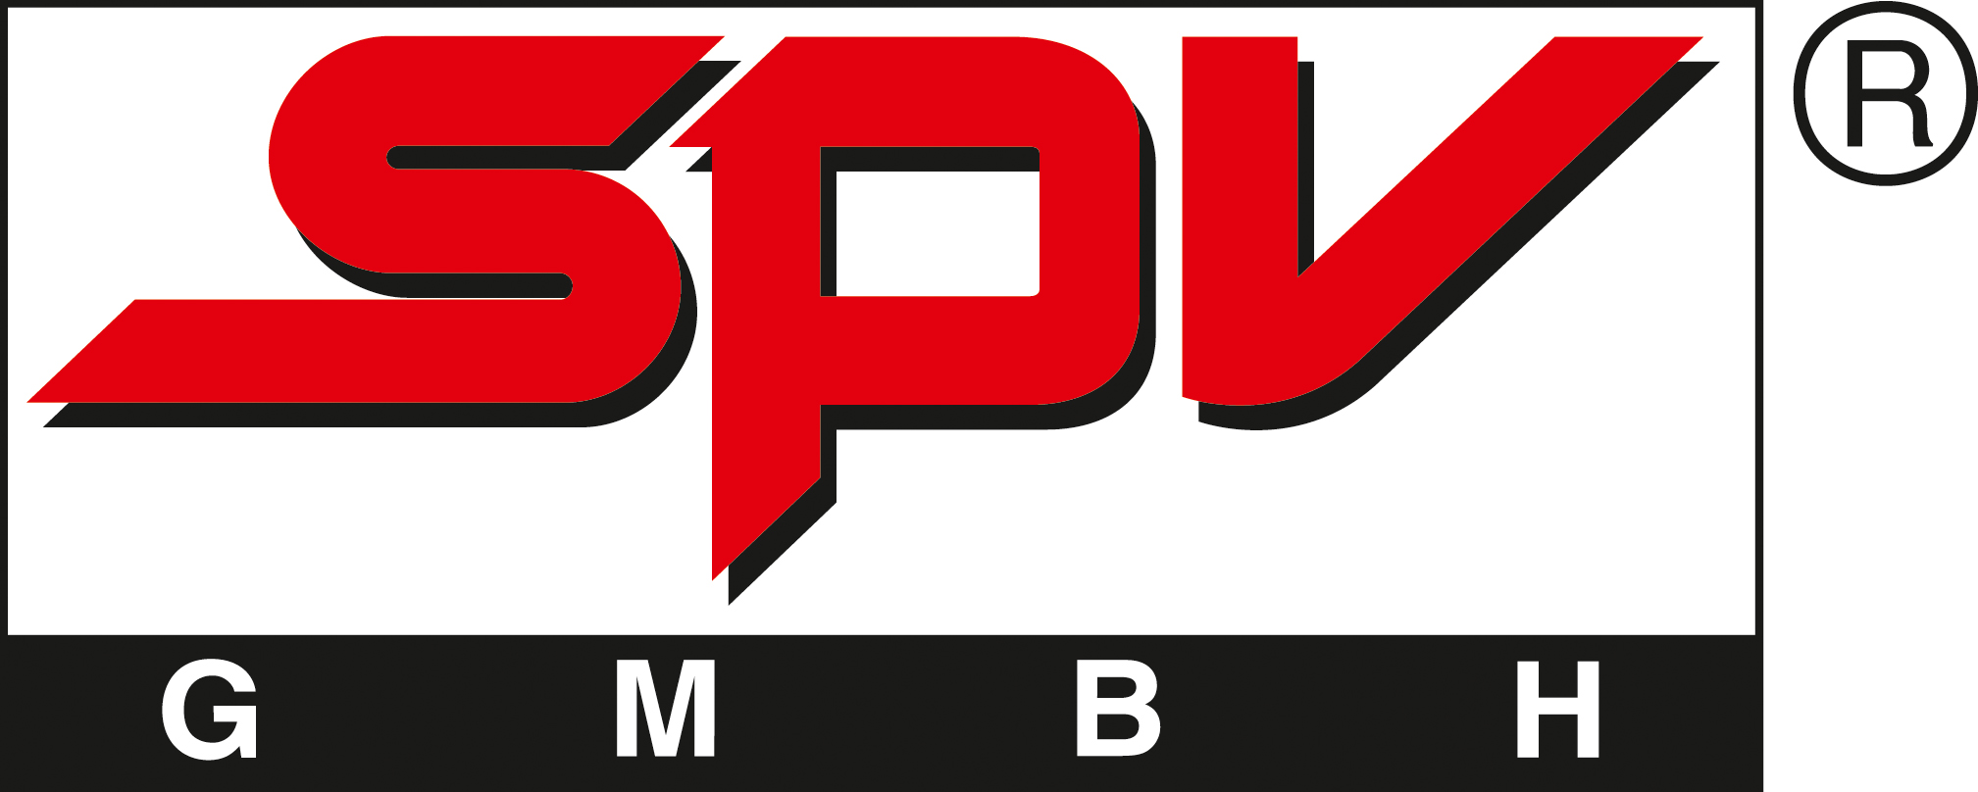
NITROGODS Release: February 24th 2012

Ex-Thunderhead and Primal Fear members Henny Wolter und Klaus Sperling´s latest strike delights even Rock´n Roll greats like Nazareth´s voice Dan McCafferty and original Motörhead guitarist Fast Eddie Clarke.
Both of them spontaniously agreed to contribute vocals and guitar to songs like Whiskey Wonderland and Wasted in Berlin.
The german threepiece, fronted by the unique singer and bassist Oimel Larcher, celebrates Rock´n Roll in a most raw and authentic way that reminds of the guitar smashing times of The Who or the early Motörhead.
It´s bad,loud and dirty and it can put tears of joy in your eyes if you love Rock´n Roll.

Video: http://www.youtube.com/watch?v=UP3P06j3w8Y
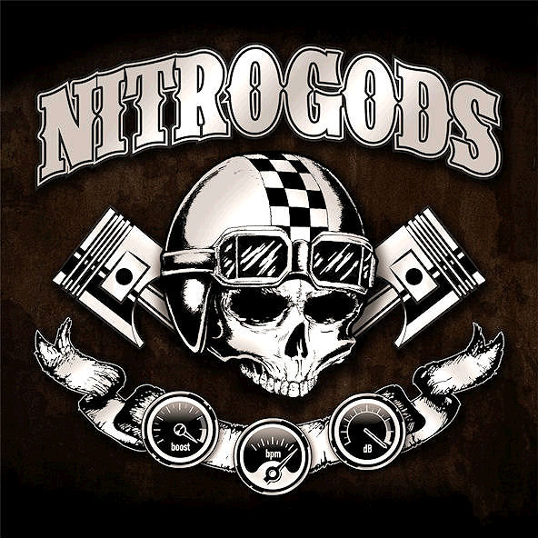
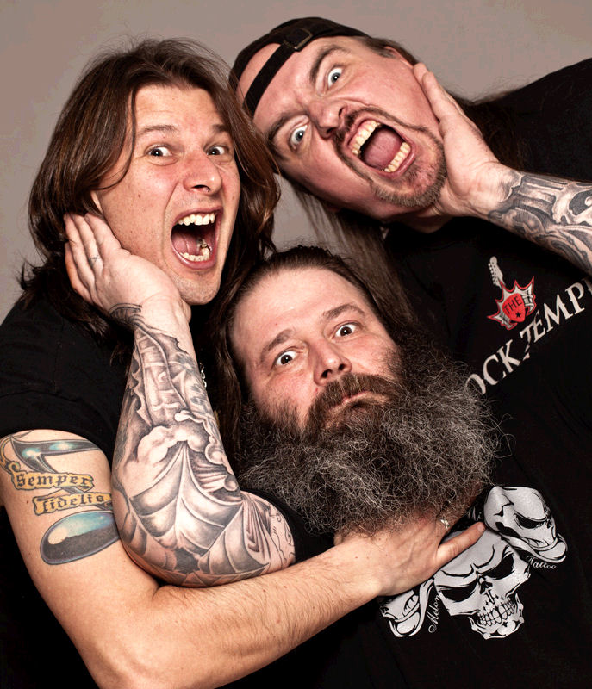
NITROGODS: ltr. Henny Wolter, Oimel Larcher, Klaus Sperling

